Last Sundays Power Outage:Update
Suggested quick fixes:
Light Sticks: 8 hours/Amazon. White.
Other colors and durations are available. 10Pk/$11
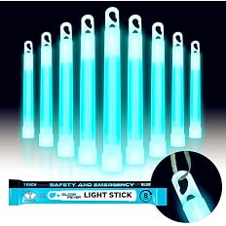
Solar/Battery Folding light
Crush Light $30 Goal Zero -There are other more advanced *(expensive) options available. Will run 24 hrs.+ on low. Solar recharge or from a computer USB port. Folds flat.
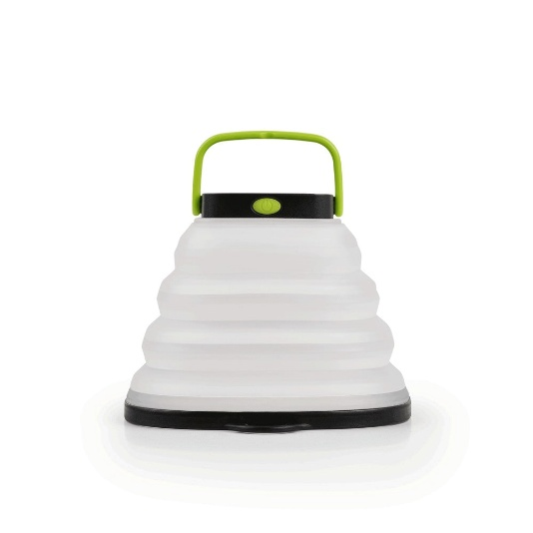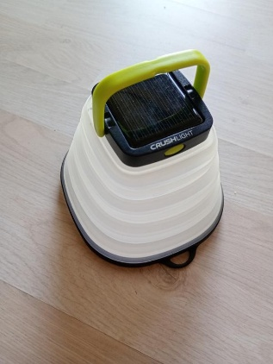
*This includes light and battery combination, mini lanterns to hang for area lighting and the tall standing emergency lights for disasters.

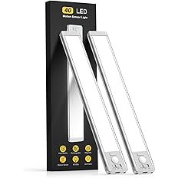
MCGOR 10inch Under Cabinet Lighting, 2 Pack Rechargeable Motion Sensor Light Indoor, 5 Levels Dimmable
These come at 10 and 14 inches. Cost between $17 AND $30 depending on size, and colors. long lasting and easy to mount with built in magnets or included adhesive backs.

Flashlights
This Amazon page has individual flashlights, Multi packs, rechargeable and battery powered. I recommend reviewing it to see what suits your needs and budget.
These include plug in, instant on an outage, stand-alone lanterns, and head band style for hands free use. Most run about $6 each or 2 for $12/14 Both battery and rechargeable are an option so read carefully. (The headband style is recommended for First Aid providers.)

